# Ryan Timbrook

## IST 659 Data Admin Concepts &Db Mgmt

## Date: 8/6/18

## Lab Assignment: Lab 4, Normalization

## Description / Learning Objective

* Demonstrate understanding normalization
* Demonstrate ability to normalize relations into at least third normal form (3NF)
* Identify candidate keys and functional dependencies and remove them from relations

## Responses:

### Part 1, Normalizing an Existing Data Set - Case Study 1 – Rad Chad’s Bikes

No response required, was informational only

### Part 1, Normalizing an Existing Data Set - Case Study 2 – More Bikes

Order(Order Num, *Cust Num,* Order Date)

Customer(Cust Num, Name, Postal Code, State)

OrderItem(Order Num, Line, *Item Number*, Qty Ordered)

Item(Item Number, Description, Price Each)

### Part 1, Normalizing an Existing Data Set - Case Study 3 – Books Again

1. Screen Print of Access Database Tables, Publisher

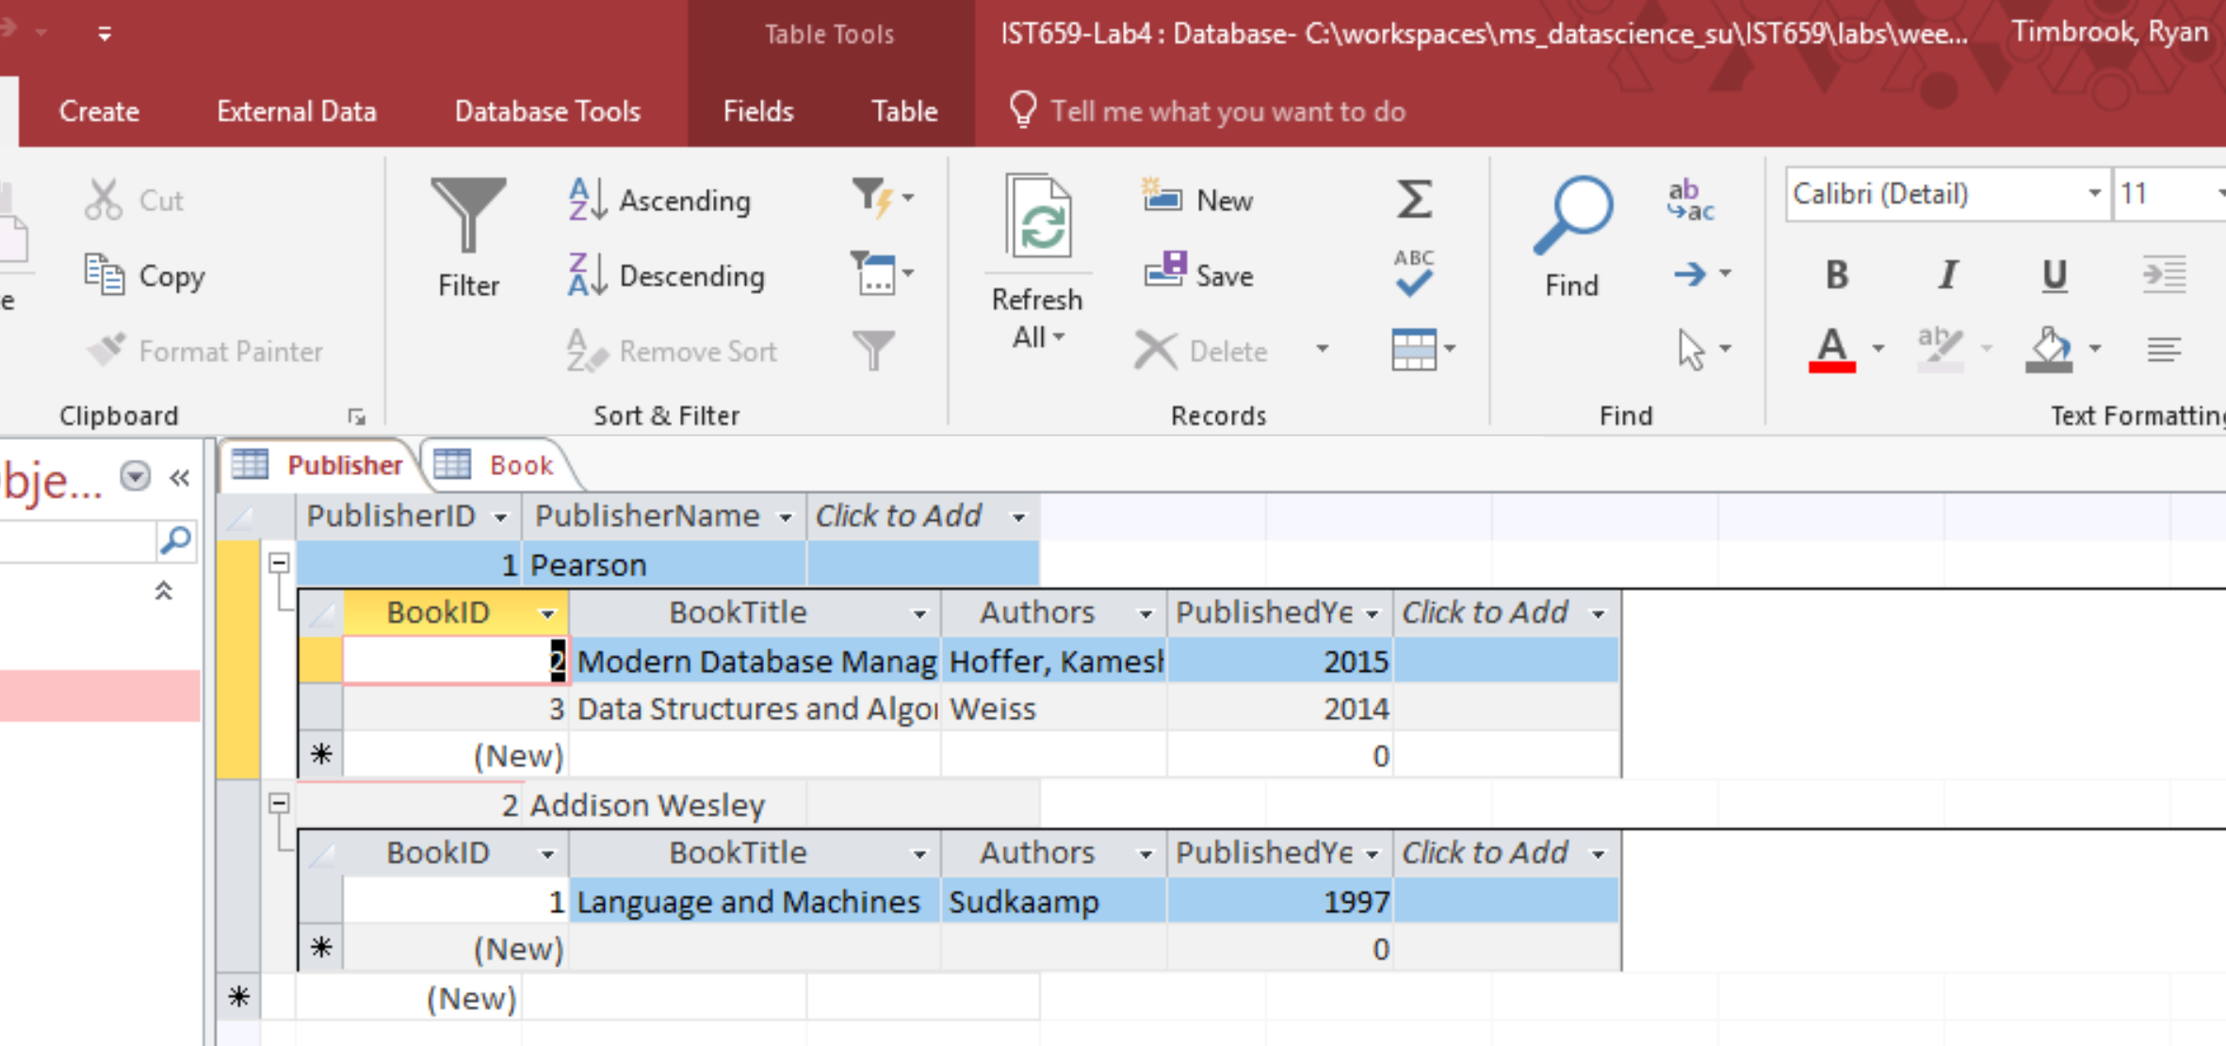

1. Authors need to be broken out into its own entity for Book to be 3NF

Book(BookID, BookTitle, *AuthorID*, PublishedYear, *PublisherID*)

Author(AuthorID, First Name, Last Name)

### Part 2, Part 1 – Normalizing Video Data for VidCast

Decompose this data set into 3NF relations:

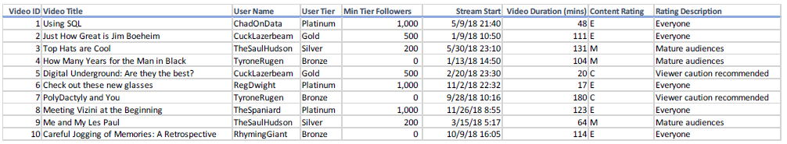

### Updated LM Model, Normalized, from Lab 3:

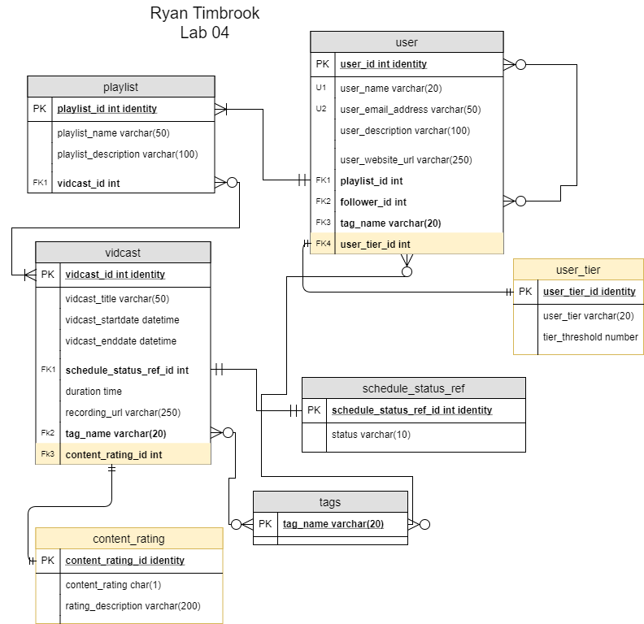

### Reference LM from Lab 3:

